THE April 27,1935

Salinas Times

Spreading news throughout the good town of Salinas

Man Breaks married woman’s neck. Flees the scene.

By: William Lester

SALINAS-Lennie Small is under suspicion for the murder of Susan Tyler yesterday in the late afternoon in Tyler Ranch’s barn. No clear motive has been established.

It occurred in the south barn around 3:00 pm. According to the eyewitness Jack Faraday, “He Showed no remorse just killed her and ran.” Faraday also took a picture of Small, however, it is very vague and does not present any new proof or evidence.

However, the laborers on the ranch like Candy Jones say otherwise. Jones claims “Lennie could have never done why he’s as sweet as Aunt Jemima”.

The Police chief, Daniel Gumshoe stated that “The autopsy suggests an instantaneous death from a broken neck.” and that it “would have required an extremely large man like that of Small’s”.

Susan Tyler is the wife of Curley Tyler who is the son of Nick Tyler. They all work at “Tyler Ranch” which Small recently joined with his partner George Milton.

Small has been connected to a case in Weed, Siskiyou County where there was a reported assault charge on a young woman was pinned on Small. However a lack of evidence for this charge forced police to drop their search.

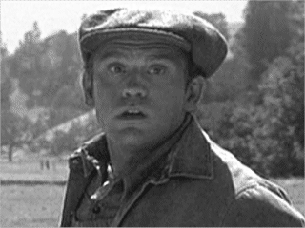

Photo taken by Jack Faraday.(April 27,1935)^{(C)}
Any motive is currently unknown but he is reportedly “Mentally Handicapped” and the common opinion was that we went insane due to the immense pressure working on this farm has caused him. He also has been known to have a delusion about living on a farm, obsessed with rabbits and clear symptoms of Schizophrenia.

The police are still searching for Small to question him on his involvement in the current case. If you see a man that resembles the picture above please alert the police immediately. The police are also asking any other possible witnesses of the crime to please come to the sheriff’s office promptly.

INSERT YOUR ARTICLE TITLE HERE

